Exercise 1:

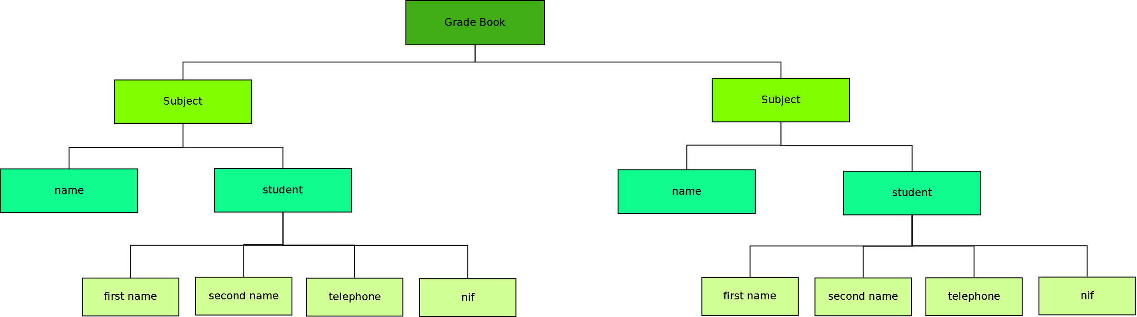

Exercise 2:
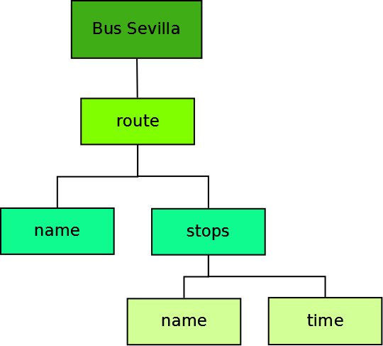

Exercise 3:

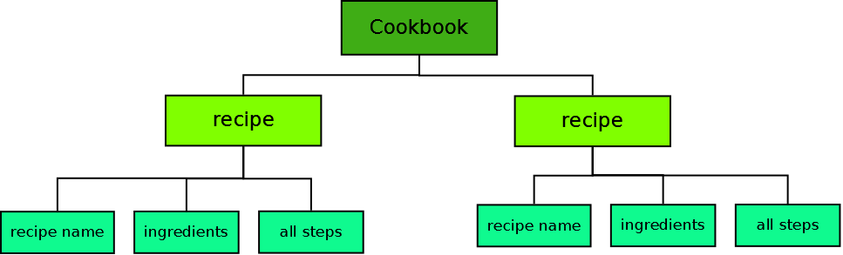

Lorenzo García Lozano

